Лабораторная работа № 1
по теме:

«Простейший синтаксический анализатор»

Выполнил:
студент 4 курса
группы ИВ-92
Петрук Вадим

Киев, 2012

Описание работы

Разработан анализатор для обработки 2х типов файлов.

При выборе обработчика файла, содержащего адреса электронной почты, результатом разбора станет список всех валидных адресов.

Описание работы обработчика файла с синтаксическими конструкциями.

Любые данные файла являются содержанием некоторой секции. Данные каждой секции хранятся в ParsedSectionData, которая является обёрткой для HashMap. Данные в ParsedSectionData разложены следующим образом:

0: Id - целочисленный уникальный Id данной секции.
1: ParentId - Id секции, в которой была создана эта секция
2: Name - имя секции
3: OptionalValue – опциональное значение
4: LineComment – список строчных комментариев, найденных в этой секции
5: BlockComment - список блоковых комментариев, найденных в этой секции
6: ParamNames - список имён параметров, найденных в этой секции
7: ParamValue - список значений параметров, найденных в этой секции

По умолчанию создаётся ParsedSectionData(0, 0, «Root Section»). Количество создаваемых внутренних секций и их вложенность не ограничены.

Все обработчики существуют в единственном экземпляре, переключение между ними происходит по целочисленному флагу в Parser. При создании новой секции текущая ParsedSectionData кладётся в стек, создаётся новая ParsedSectionData и объявляется текущей. Если секция закрывается, то эта ParsedSectionData коммитится в список разобранных данных, а её место занимает поднятая из стека ParsedSectionData. При обработке конца файла коммитится ParsedSectionData корневой секции. Наличие в файле незакрытой секции является синтаксической ошибкой.

Схема автомата E-mail парсера:
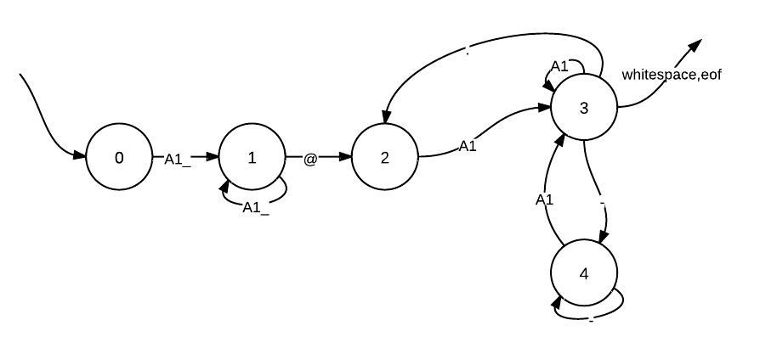
Схема автомата парсера коментариев
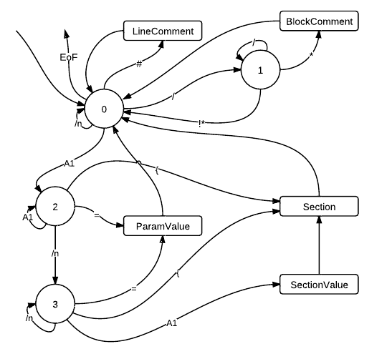

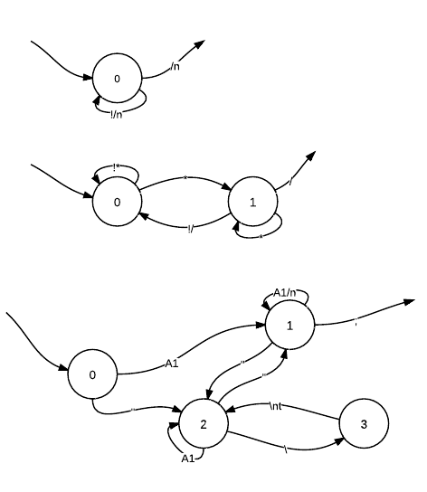
- LineComment
- BlockComment
- ParamValue
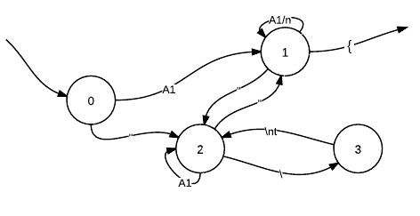
- SectionalValue

package lab1;

import java.nio.charset.Charset;
import java.nio.charset.StandardCharsets;
import java.nio.file.Path;
import java.nio.file.Paths;
import java.text.CharacterIterator;
import java.text.StringCharacterIterator;
import java.util.ArrayList;
import java.util.Scanner;

/**
* Created by IntelliJ IDEA.
* User: Nightingale
* Date: 9/9/12
* Time: 11:57 AM
* To change this template use File | Settings | File Templates.
*/
public class Parser {

private final Charset ENCODING = StandardCharsets.UTF_8;
private DataParser dataParser;
private int typeOfParser;

private static MainParser mainParser;
private static LineCommentParser lineCommentParser;
private static BlockCommentParser blockCommentParser;
private static ValueParamParser valueParamParser;
private static ValueSectionParser valueSectionParser;
private static EmailParser emailParser;

private static final int MainParserMarker = 0;
private static final int LineCommentParserMarker = 1;
private static final int BlockCommentParserMarker = 2;
private static final int ValueParamParserMarker = 3;
private static final int ValueSectionParserMarker = 4;

private static final int FileParserFlag = 1;
private static final int EmailParserFlag = 2;

private static int userFlag;

public Parser(DataParser dataParser) {
this.dataParser = dataParser;

typeOfParser = 0;

}

public void setTypeOfParser(int typeOfParser) {
this.typeOfParser = typeOfParser;
}

public static void main(String[] args) {

userFlag = FileParserFlag;

mainParser = new MainParser();
blockCommentParser = new BlockCommentParser(mainParser);
lineCommentParser = new LineCommentParser(mainParser);
valueParamParser = new ValueParamParser(mainParser);
valueSectionParser = new ValueSectionParser(mainParser);

emailParser = new EmailParser();

Parser parser = new Parser(mainParser);
// Parser parser = new Parser(emailParser);

// parser.setTypeOfParser(7);

try {

parser.parseMessage("input.txt");
} catch (Exception e) {
e.printStackTrace();
}
}

public void parseMessage(String fileName) throws Exception{

if (dataParser == null) {
throw new Exception("Type of data parser is not defined!") ;
}

Path path = Paths.get(fileName);
int tempType = 0;

try (Scanner scanner = new Scanner(path, ENCODING.name())) {
while (scanner.hasNextLine()) {
StringCharacterIterator iterator = new StringCharacterIterator(scanner.nextLine());

for (char symbol = iterator.first(); symbol != CharacterIterator.DONE; symbol = iterator.next()) {
tempType = dataParser.handleSymbol(symbol);
if ((tempType!=typeOfParser) && (typeOfParser != 7)){
typeOfParser = tempType;
switchParser(symbol);
dataParser.reset();
}
}

tempType = dataParser.handleSymbol('\n');
if (typeOfParser != 7){
if (tempType!=typeOfParser){
typeOfParser = tempType;
switchParser('\n');
dataParser.reset();
}
}

}
dataParser.handleEof();

if (typeOfParser != 7){
ArrayList<ParsedSectionData> data = mainParser.getData();
for (ParsedSectionData object : data)
System.out.println(object.toString());
}

}

}

public void switchParser(char ch){
switch (typeOfParser){
case MainParserMarker:
dataParser = mainParser;
System.out.println("now mainParser is active, current char is "+ch);
break;

case LineCommentParserMarker:
dataParser = lineCommentParser;
System.out.println("now lineCommentParser is active, current char is "+ch);
break;

case BlockCommentParserMarker:
dataParser = blockCommentParser;
System.out.println("now blockCommentParser is active, current char is "+ch);
break;

case ValueParamParserMarker:
dataParser = valueParamParser;
System.out.println("now valueParamParser is active, current char is "+ch);
break;

case ValueSectionParserMarker:

valueSectionParser.addFirstSymbol(ch);
dataParser = valueSectionParser;
System.out.println("now valueSectionParser is active, current char is "+ch);
break;

}
}

}

package lab1;

import java.util.ArrayList;

/**
* Created by IntelliJ IDEA.
* User: Nightingale
* Date: 9/9/12
* Time: 12:00 PM
* To change this template use File | Settings | File Templates.
*/
public interface DataParser {

public int handleSymbol(char symbol) throws Exception;
public void reset();
public String getTypeOfParser();
public void handleEof() throws Exception;

}
package lab1;

import java.util.ArrayList;
import java.util.HashMap;
import java.util.Stack;

/**
* Created by IntelliJ IDEA.
* User: Nightingale
* Date: 9/10/12
* Time: 12:05 AM
* To change this template use File | Settings | File Templates.
*/
public class MainParser implements DataParser {

private String currentString;
private HashMap<Character, Integer> map;
private ParsedSectionData currentParsedSectionData;
private ArrayList<ParsedSectionData> listOfSections;

private int currentState;
private Stack<ParsedSectionData> stack;

private static final int C1 = 1; //create sharp comment
private static final int C2 = 2; //create slash comment
private static final int C3 = 3; //create paramValue, save paramName
private static final int C4 = 4; //create Section, save sectionName
private static final int C5 = 5; //create sectionValue
private static final int E1 = 6; //error1 - unexpected symbol
private static final int E2 = 7; //error2 - try to create unnamed section
private static final int WR = 8; //add char to currentString
private static final int CS = 9; //try to close section
private static final int E3 = 10; //* without /
private static final int E4 = 11; //try to create param value without name
private static final int E5 = 12; //unknown symbol
private static final int E6 = 13; //expected for *, recieved other symbol
private static final int E7 = 14; //try to create coment in bad place

private int numberOfSection;

private int flag = 0; //flag = 0 if main parser is active

private int[][] nextStateTable =
{{2,0,2,0}, // 0 a1
{0,0,0,0}, // 1 #
{1,0,0,0}, // 2 /
{0,0,0,0}, // 3 *
{0,0,3,3}, // 4 white space
{0,0,0,0}, // 5 =
{0,0,0,0}, // 6 {
{0,0,0,0}, // 7 OTHER
{0,0,0,0}}; // ;

private int[][] actionTable =
{{WR,E6,WR,C4}, //0
{C1,E6,E7,E7}, //1 !!!
{ 0,E6,E7,E7}, //2
{E3,C2,E1,E1}, //3
{0,E6,0,0}, //4
{E4,E6,C3,C3}, //5
{E2,E6,C5,C5}, //6
{E5,E6,E5,E5}, //7
{CS,E6,CS,CS}}; //8

public MainParser() {

stack = new Stack();
numberOfSection = 1;
currentString = "";
currentState = 0;

currentParsedSectionData = new ParsedSectionData(0,0,"Root Section") ;
listOfSections = new ArrayList<>();

map = new HashMap<>();

for (char i = 'a'; i < 'z'; i++) {
map.put(i, 0);
map.put(Character.toUpperCase(i), 0);
}
for (char i = '0'; i < '9'; i++) {
map.put(i, 0);
}

map.put('#', 1);
map.put('/', 2);
map.put('*', 3);
map.put(' ', 4);
map.put('\n', 4);
map.put('=', 5);
map.put('{', 6);
map.put('}', 8);

}

public int handleSymbol(char symbol) throws Exception {

int action;

int row = map.containsKey(symbol) ? map.get(symbol) : 7;
int newState = nextStateTable[row][currentState];
// System.out.println("symbol = "+symbol+"; toAct = actionTable["+row+"]["+currentState+"]");

action = actionTable[row][currentState];
currentState = newState;

flag = processAction(action,symbol);
return flag;
}

private int processAction(int action, char item) throws Exception {

switch (action) {
case WR:
currentString += item;
flag = 0;
break;
case E1:
throw new Exception("main parser: unexpected symbol received");
case E2:
throw new Exception("main parser: try to open unnamed section");
case E3:
throw new Exception("main parser: received '*' without '/'; can't create block comment");
case E4:
throw new Exception("main parser: attempt to assign a value to unnamed parameter");
case E5:
throw new Exception("main parser: unknown symbol recieved");
case E6:
throw new Exception("main parser: expected for '*', recieved other symbol");
case E7:
throw new Exception("main parser: bad place for creating comment");

case C1: //create line comment
flag = 1;
reset();
break;

case C2: //create block comment
flag = 2;
reset();
break;

case C3: //create paramValue, save paramName
addData(6, currentString);

flag = 3;
reset();
break;

case C4: //create Section, save sectionName
int parentId = currentParsedSectionData.getId();
stack.push(currentParsedSectionData);

currentParsedSectionData = new ParsedSectionData(numberOfSection,parentId,currentString);
numberOfSection++;
reset();
flag = 4;
reset();
break;

case C5: //create sectionValue
flag = 0;
parentId = currentParsedSectionData.getId();
stack.push(currentParsedSectionData);

currentParsedSectionData = new ParsedSectionData(numberOfSection,parentId,currentString);
numberOfSection++;
reset();
break;

case CS :

if (stack.empty())
throw new Exception("recieved '}', but there is no section for close");
else {
listOfSections.add(currentParsedSectionData);
currentParsedSectionData = stack.pop();
}

case 0:
flag = 0;
break;

}
return flag;
}

public void reset() {
currentString = "";
}

@Override
public String getTypeOfParser() {
return "MainParser";
}

public String getResult() {
return null;
}

public void addData(Integer i, String s){
currentParsedSectionData.addData(i,s);

}

public ArrayList<ParsedSectionData> getData(){
listOfSections.add(currentParsedSectionData);
return listOfSections;
}

@Override
public void handleEof() throws Exception{
if (!stack.empty())
throw new Exception("Some section isn't closed") ;
}
}
package lab1;

import java.util.HashMap;

/**
* Created by IntelliJ IDEA.
* User: Nightingale
* Date: 9/9/12
* Time: 5:56 PM
* To change this template use File | Settings | File Templates.
*/
public class LineCommentParser implements DataParser{

private String commentText;
private HashMap<Character, Integer> map;
private int currentState;
private MainParser mainParser;

private final int W = 0;
private final int Q = 1;
private int flag;

private int[][] nextStateTable = {{0},
{1}};
private int[][] actionTable = {{W},
{Q}};

public LineCommentParser(MainParser m){
mainParser = m;
commentText = "";
currentState = 0;
flag = 1;

map = new HashMap<>();
map.put('\n', 1); //TODO fix @ to \n

}

@Override
public String getTypeOfParser() {
return "LineCommentParser";
}

public int handleSymbol(char symbol) {

flag = 1;

int row = map.containsKey(symbol)? map.get(symbol) : 0;
int newState = nextStateTable[row][currentState];

int action = actionTable[row][currentState];
currentState = newState;
flag = processAction(action, symbol);
return flag;

}

private int processAction(int action, char item) {
switch (action) {
case W:
commentText += item;
break;
case Q:
//forReturn = commentText;
mainParser.addData(4,commentText);
flag = 0;
reset();
currentState = 0;
break;
}
return flag;
}

public void reset(){
commentText = "" ;
}

@Override
public void handleEof() throws Exception{
//To change body of implemented methods use File | Settings | File Templates.
}
}
package lab1;

import java.util.HashMap;

/**
* Created by IntelliJ IDEA.
* User: Nightingale
* Date: 9/9/12
* Time: 2:22 PM
* To change this template use File | Settings | File Templates.
*/
public class BlockCommentParser implements DataParser{

private String commentText;
private HashMap<Character, Integer> map;
private int currentState;
private MainParser mainParser;

private static final int W = 1; //add to commentText
private static final int Q = 3; //quite with save

private int[][] nextStateTable =
{{0,0}, //letters and numbers
{1,1}, // *
{0,0}, // /
{0,0}}; //other symbol

private int[][] actionTable =
{{W,W},
{W,W},
{W,Q},
{W,W}};

private int flag;

public BlockCommentParser(MainParser m){

mainParser = m;
commentText = "";
currentState = 0;

map = new HashMap<>();

for (char i = 'a'; i < 'z'; i++) {
map.put(i, 0);
map.put(Character.toUpperCase(i), 0);
}
for (char i = '0'; i < '9'; i++) {
map.put(i, 0);
}

map.put('*', 1);
map.put('/', 2);

}

@Override
public int handleSymbol(char symbol) {

flag = 2;
int row = map.containsKey(symbol)? map.get(symbol) : 3;
int newState = nextStateTable[row][currentState];

int action = actionTable[row][currentState];
currentState = newState;
flag = processAction(action, symbol);

return flag;
}

private int processAction(int action, char item) {
switch (action) {
case W:
commentText += item;
break;
case Q:
mainParser.addData(5,commentText.substring(0,(commentText.length() - 1)));
flag = 0;
reset();
break;
}
return flag;
}

public void reset(){
commentText = "" ;
currentState = 0;
}

@Override
public String getTypeOfParser() {
return "BlockCommentParser"; //To change body of implemented methods use File | Settings | File Templates.
}

@Override
public void handleEof() throws Exception {
throw new Exception("unexpected EoF during processing block comment");
}
}
package lab1;

import java.util.HashMap;

/**
* Created by IntelliJ IDEA.
* User: Nightingale
* Date: 9/9/12
* Time: 6:07 PM
* To change this template use File | Settings | File Templates.
*/
public class ValueParamParser implements DataParser{

private String currentValue;
private HashMap<Character, Integer> map;
private int currentState;
private String forReturn;
private MainParser mainParser;

private int flag;

private static final int W = 1; //add to value
private static final int Q = 2; //save and quit
private static final int E = 3; //error
private static final int E1 = 4; //error wrong symbol after \
private static final int E2 = 5; //empty param value

//TODO fix \\, \", \n, \t process

private int[][] nextStateTable =
{{1,1,2,0}, //0 letters and number except n and t
{2,2,1,2}, //1 "
{3,1,3,2}, //2 \
{1,1,2,2}, //3 n t
{0,0,0,0}, //4 ;
{1,1,2,0}}; //5 other symbol

private int[][] actionTable =
{{W,W,W,E1},
{W,W,W,W},
{W,W,W,W},
{W,W,W,W},
{E2,Q,W,E1},
{W,W,W,E1}};

public ValueParamParser(MainParser m){

mainParser = m;

currentValue = "";
currentState = 0;
flag = 3;

map = new HashMap<>();

for (char i = 'a'; i < 'm'; i++) {
map.put(i, 0);
map.put(Character.toUpperCase(i), 0);
}

for (char i = 'o'; i < 's'; i++) {
map.put(i, 0);
map.put(Character.toUpperCase(i), 0);
}

for (char i = 'u'; i < 'z'; i++) {
map.put(i, 0);
map.put(Character.toUpperCase(i), 0);
}

for (char i = '0'; i < '9'; i++) {
map.put(i, 0);
}

map.put('"', 1);
map.put('\\', 2);
map.put('n', 3);
map.put('t', 3);
map.put(';', 4);
}

@Override
public String getTypeOfParser() {
return "ValueParamParser";
}

public int handleSymbol(char symbol) throws Exception {

int row = map.containsKey(symbol)? map.get(symbol) : 5;
int newState = nextStateTable[row][currentState];
int action = actionTable[row][currentState];
currentState = newState;

flag = processAction(action, symbol);

return flag;

}
private int processAction(int action, char item) throws Exception{
switch (action) {

case W:
flag = 3;
currentValue += item;
break;
case Q:
mainParser.addData(7,currentValue);
flag = 0;
reset();
break;
case E1:
throw new Exception("exception during processing param value: wrong symbol after backSlash");

case E2:
throw new Exception("exception during processing param value: value == null");
}
return flag;
}

public void reset(){
currentValue = "";
currentState = 0;
}

@Override
public void handleEof() throws Exception {
throw new Exception("unexpected EoF during processing param value");
}
}
package lab1;

import java.util.HashMap;

/**
* Created by IntelliJ IDEA.
* User: Nightingale
* Date: 9/9/12
* Time: 6:07 PM
* To change this template use File | Settings | File Templates.
*/
public class ValueSectionParser implements DataParser{

private String currentValue;
private HashMap<Character, Integer> map;
private int currentState;
private char tempFirstChar;
private String forReturn;
private MainParser mainParser;

private static final int W = 1; //add to value
private static final int Q = 2; //save and quit
private static final int E = 3; //error

private int flag;

//TODO fix \\, \", \n, \t process

private int[][] nextStateTable =
{{1,1,2,0}, //0 letters and number except n and t
{2,2,1,2}, //1 "
{3,1,3,2}, //2 \
{1,1,2,2}, //3 n t
{0,0,0,0}, //4 {
{1,1,2,0}}; //5 other symbol

private int[][] actionTable =
{{W,W,W,E},
{W,W,W,W},
{W,W,W,W},
{W,W,W,W},
{Q,Q,E,E},
{W,W,W,E}};

public ValueSectionParser(MainParser m){

mainParser = m;

currentValue = "";
currentState = 0;
flag = 4;

map = new HashMap<>();

for (char i = 'a'; i < 'm'; i++) {
map.put(i, 0);
map.put(Character.toUpperCase(i), 0);
}

for (char i = 'o'; i < 's'; i++) {
map.put(i, 0);
map.put(Character.toUpperCase(i), 0);
}

for (char i = 'u'; i < 'z'; i++) {
map.put(i, 0);
map.put(Character.toUpperCase(i), 0);
}

for (char i = '0'; i < '9'; i++) {
map.put(i, 0);
}

map.put('"', 1);
map.put('\\', 2);
map.put('n', 3);
map.put('t', 3);
map.put('{', 4);

}

public void addFirstSymbol(char ch){
tempFirstChar = ch;
}

public int handleSymbol(char symbol) throws Exception {

flag = 4;
int row = map.containsKey(symbol)? map.get(symbol) : 5;
int newState = nextStateTable[row][currentState];
int action = actionTable[row][currentState];
currentState = newState;
flag = processAction(action, symbol);

return flag;
}

@Override
public String getTypeOfParser() {
return "ValueSectionParser";
}

private int processAction(int action, char item) throws Exception {
switch (action) {

case W:
flag = 4;
if (currentValue.equals(""))
currentValue+=tempFirstChar;
currentValue += item;
break;
case Q:
if (currentValue.equals(""))
currentValue+=tempFirstChar;
mainParser.addData(3,currentValue);
flag = 0;
reset();
break;
case E:
throw new Exception("exception during processing optional section value: wrong symbol after backSlash");
}
return flag;
}

public void reset(){
currentValue = "";
currentState = 0;
}

@Override
public void handleEof() throws Exception {
throw new Exception("unexpected EoF during processing optional section value");
}
}
package lab1;

import java.util.ArrayList;
import java.util.HashMap;

/**
* Created by IntelliJ IDEA.
* User: Nightingale
* Date: 9/12/12
* Time: 12:37 PM
* To change this template use File | Settings | File Templates.
*/
public class ParsedSectionData {
HashMap<Integer,ArrayList<String>> sectionData;
private final int IdIndex = 0;
private final int ParentIdIndex = 1;
private final int NameIndex = 2;
private final int OptionalValueIndex = 3;
private final int LineCommentIndex = 4;
private final int BlockCommentIndex = 5;
private final int ParamNamesIndex = 6;
private final int ParamValueindex = 7;

public ParsedSectionData(int id, int parentId, String name){
sectionData = new HashMap<>();
addData(IdIndex, Integer.toString(id));
addData(ParentIdIndex, Integer.toString(parentId));
addData(NameIndex, name);
}

public void addData(Integer i, String s){
ArrayList<String> temp = new ArrayList<>();
if (sectionData.get(i) != null)
temp = sectionData.get(i);
temp.add(s);
sectionData.put(i,temp);

}

public int getId(){
ArrayList<String> temp = sectionData.get(0);
String s = temp.get(0);
return Integer.parseInt(s);
}

@Override
public String toString() {
return "Section{" +
"sectionContent=" + sectionData +
'}';
}
}
package lab1;

import java.util.ArrayList;
import java.util.HashMap;

public class EmailParser implements DataParser{
private String body = "";
private String domain = "";
private HashMap<Character, Integer> map;
private ArrayList<String> emails;
private int currentState;

private static final int N = 1;
private static final int D = 2;
private static final int S = 3;
private static final int R = 4;

private int[][] nextStateTable =
{{1,1,3,3,3},
{1,1,0,0,0},
{0,2,0,0,0},
{0,0,0,4,4},
{0,0,0,0,0},
{0,0,0,2,0},
{0,0,0,0,0}};

private int[][] actionTable =
{{N,N,D,D,D},
{N,N,R,R,R},
{R,0,R,R,R},
{R,R,R,D,D},
{R,R,R,S,R},
{R,R,R,D,R},
{R,R,R,R,R}};

public EmailParser() {

currentState = 0;
emails = new ArrayList<>();
map = new HashMap<>();
for (char i = 'a'; i < 'z'; i++) {
map.put(i, 0);
map.put(Character.toUpperCase(i), 0);
}
for (char i = '0'; i < '9'; i++) {
map.put(i, 0);
}
map.put('_', 1);
map.put('@', 2);
map.put('-', 3);
map.put(' ', 4);
map.put('\n',4);
map.put('.', 5);
}

public void handleEof() {
System.out.println(emails);
// act(actionTable[6][state - 1], ' ');
}

private void act(int action, char item) {
switch (action) {
case N:
body += item;
break;
case D:
domain += item;
break;
case S:
emails.add(body + "@" + domain);
reset();
break;
case R:
reset();
break;
}
}

@Override
public int handleSymbol(char symbol) throws Exception {
int row = map.containsKey(symbol)? map.get(symbol) : 6;

int newState = nextStateTable[row][currentState];
// System.out.println("symbol = "+symbol+"; toAct = actionTable["+row+"]["+newState+"] || name = "+body+" ;domain = "+domain );

int action = actionTable[row][currentState];
currentState = newState;
act(action, symbol);

return 7;
}

public void reset() {
body = "";
domain = "";
}

public String getTypeOfParser() {
return "Email parser"; //To change body of implemented methods use File | Settings | File Templates.
}

}
Работа email парсера:

Текст исходного файла:
try@try
try@try.io
_yu__@ki.op.op
io.io@pola.
jo123@ko.o
op @jf
jor@ko--.mo
jora@ko--m.mako
po@-io.monta

Результат
try@try, try@try.io, _yu__@ki.op.op, jo123@ko.o, jora@ko--m.mako

Работа текстового парсера

Текст исходного файла:
yokogava = somevalue "string \n also" join; #some comment 1
/***/
/*kokoko*//*kakaka*/#smile!
goDeeper optVal {
againDeeper {
andAgain yes{ }

someParam = moooooonster"afraid\t";
/*gogo*/
/*gogo222*/ patras = kandibober; #holyshit
}
onemore try{sun = rain;}
}
packman = omnomnom;
girlfriend {#oops!
}

#bye!

Результат:
Section{sectionContent={0=[3], 1=[2], 2=[andAgain], 3=[yes]}}
Section{sectionContent={0=[2], 1=[1], 2=[againDeeper], 4=[holyshit], 5=[gogo, gogo222], 6=[someParam, patras], 7=[ moooooonster"afraid\t", kandibober]}}
Section{sectionContent={0=[4], 1=[1], 2=[onemore], 3=[try], 6=[sun], 7=[ rain]}}
Section{sectionContent={0=[1], 1=[0], 2=[goDeeper], 3=[optVal ]}}
Section{sectionContent={0=[5], 1=[0], 2=[girlfriend], 4=[oops!]}}
Section{sectionContent={0=[0], 1=[0], 2=[Root Section], 4=[some comment 1, smile!, bye!], 5=[*, kokoko, kakaka], 6=[yokogava, packman], 7=[ somevalue "string \n also" join, omnomnom]}}

